Literature Review

The project is a comparative study of Regenerative Braking Energy recovery between three motors IM, BLDC and SynRM. The project can be broken down into two main segments, the first segment primarily deals with the electric vehicle modelling and driver influence with braking. The second segment comprises of the comparison of the three motors.

Several studies have been performed to develop model and simulate hybrid electric vehicles and Electric vehicles[prf]. The paper by J.Wang, I.Besselink and H.Nijmeijer [prf] proposes the energy consumption modelling and prediction based on road information. It takes into account the dependency of characteristic vehicle parameters on different driving and weather conditions as shown in table 1.

Table : Dependency of Characteristic Parametres.

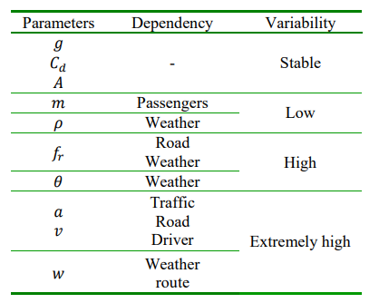

It implements a parallel braking system. It discusses the safe use of the Regenerative braking in the EV. The regenerative braking is a function of the percentage of brake pedal depression. Arguing that at speeds greater than 60km/hr, when the brake pedal is depressed more than 60%, the regenerative braking is reduced to zero and mechanical braking is only applied to ensure braking stability in case of emergency. It also highlights the powertrain efficiency in traction and regenerative braking mode.

